EEL-4742L Advanced Microprocessor Based System Design Lab Report

Section No: 1
Lab Instructor: Angel Salges
Lab No: 2
Lab Title: Introduction to the MSP432 Peripheral Driver Library
Name: Jacob Bachle
Partner’s Name: Rafael Cano
Date Performed: 1/27/26
Date Delivered: 1/27/26

Contents
EEL-4742LAdvanced Microcontroller Based Systems Design Lab Report 1
1. Introduction 3
2. Design Requirements 3
3. Theoretical Design 3
4. Synthesized Design 4
5. Experimental Results 4
6. Summary 4
7. Lessons Learned 5

Introduction
While using register level code may be versatile. Driver library or Software Development Kit (SDK) functions are much more readable. Readability is important if a function needs to be used for other purposes. Or the functionality of the function needs to be adapted for other use. The conversion from register level code to MSP432 Driver library code is demonstrated through the modification of a previous lab to use driver library functions instead of register level code. Previously, register level code was used to toggle the frequency of leds and change the color of an colored LED.

Design Requirements
When the device is powered on, LED 1 and the colored LEDs are all turned off and not blinking.

When switch 1 (S1), located on the left side of the board, LED 1 can be toggled to blink at the following frequencies, 1, 2, 4, and 0 (Off) Hz. The states are toggled when S1 is released.

When switch 2 (S2), located on the right side of the board, the colored LEDS can be toggled to different colors. The colors are Yellow, Cyan, Magenta, None (Off). The states are toggled when S2 is released.

The colored LEDs also toggle at the same frequency as controlled by S1

Theoretical Design
Step 1 pseudocode:
- Stop Watch Dog Timer (WDT) using "MAP_WDT_A_holdTimer();"
- Config RED LED 1 and RED LED 2 as a GPIO output. Using "MAP_GPIO_setAsOutputPin(GPIO_PORT_Px, GPIO_PINy);"
- Set RED LED 1 and 2 to low.
- Spin
  - Toggle RED LED 1 using "MAP_GPIO_toggleOutputOnPin(GPIO_PORT_Px, GPIO_PINy);"
  - Toggle RED LED 2 using "MAP_GPIO_toggleOutputOnPin(GPIO_PORT_Px, GPIO_PINy);"
  - Delay loop (0.5s)

Step 4 pseudocode:
- Stop WDT
- Set global variables
- Define function prototypes
- Define typedef enum for LED 1 and 2 state.
- Define default state using typedefs. (blink frequency, color pattern) = (OFF, OFF).
- Set / clear timer source to default frequency use "myTimerDelay" for timer
- Configure GPIO defined in line 10
- Configure input interrupts defined in line X
- Spin
  - Poll to update LED 1 default states (If Px IFG is set high, update state) S1 (P1.1). If(P1-> & BIT1).
  - Poll to update LED 2 default typedefs (If Px IFG is set high, update state) S2 (P1.4). If(P1-> & BIT4).
  - Switch case to set pattern to LED 1
  - Switch case to toggle RED LED 2 then using "myTimerDelay", delay time associated with desired frequency.
- myTimerDelay
  - Defined in lab 2 instructions
- configureGPIO
  - Set RED LED 1 as GPIO output.
  - Set RED LED 2 as GPIO output
  - Set all GPIO outputs to low.
- configureInputInterupts
  - Set S1 (P1.1) and S2 (P1.2) as GPIO input.
  - Enable enable pull-up/pull-down resistor on pin for S1 and S2.
  - Select pull-up resistor for S1 and S2.
  - Enable interupt on pin for S1 and S2.
  - Select high to low interupt edge for S1 and S2.
  - Clear interupts for S1 and S2.

Step 5 pseudocode:
- Stop WDT
- Set global variables
- Define function prototypes
- Define typedef enum for blink frequency and color pattern.
- Define default state using typedefs. (blink frequency, color pattern) = (Zero, OFF).
- Set / clear timer source to default frequency use "myTimerDelay" for timer
- Configure GPIO defined in line 10
- Configure input interrupts defined in line X
- Spin
  - Poll to update blink frequency default states (If Px IFG is set high, update state) S1 (P1.1). If(P1-> & BIT1).
  - Poll to update color pattern typedefs (If Px IFG is set high, update state) S2 (P1.4). If(P1-> & BIT4).
  - Switch case to set pattern to current pattern
  - Switch case to toggle RED LED 1 then using "myTimerDelay", delay time associated with desired frequency.
- myTimerDelay
  - Defined in lab 2 instructions
- configureGPIO
  - Set RED LED 1 as GPIO output.
  - Set YELLOW, CYAN, and MAGENTA LED as GPIO output.
  - Set all GPIO outputs to low.
- configureInputInterupts
  - Set S1 (P1.1) and S2 (P1.2) as GPIO input.
  - Enable enable pull-up/pull-down resistor on pin for S1 and S2.
  - Select pull-up resistor for S1 and S2.
  - Enable interupt on pin for S1 and S2.
  - Select high to low interupt edge for S1 and S2.
  - Clear interupts for S1 and S2.

Synthesized Design

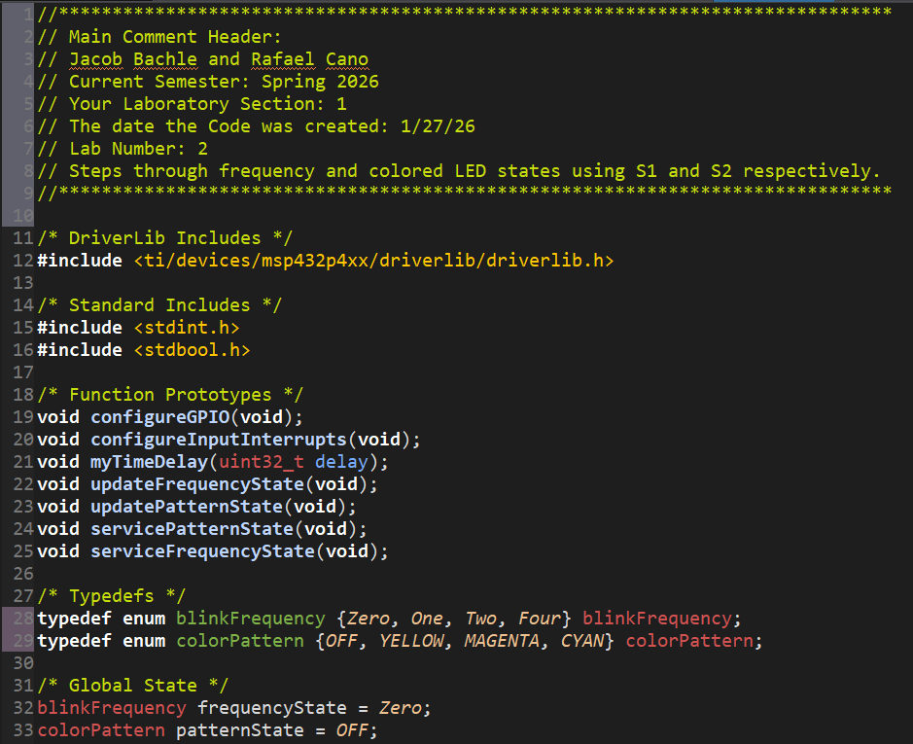
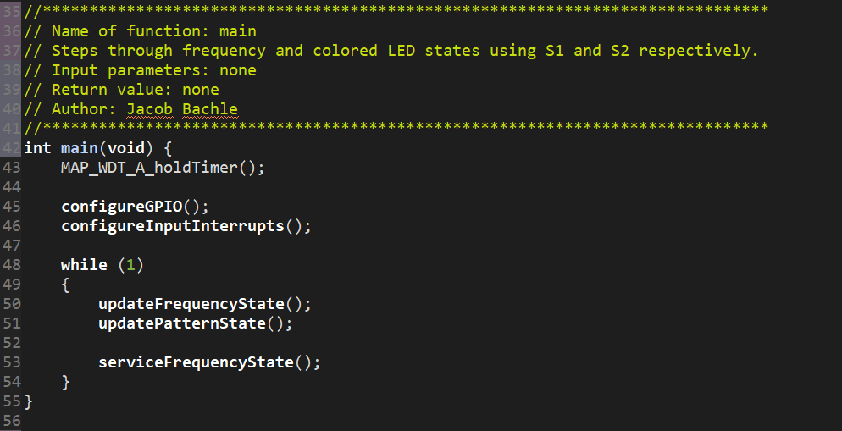
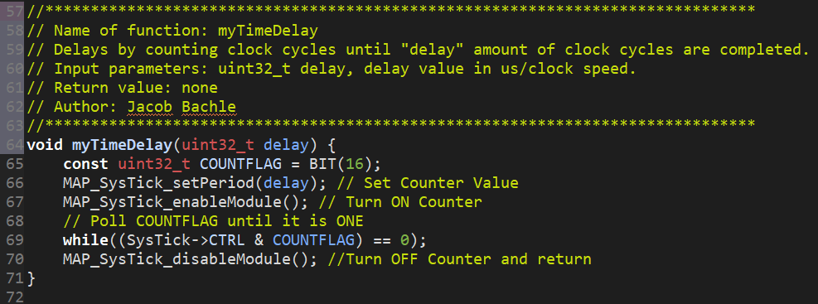
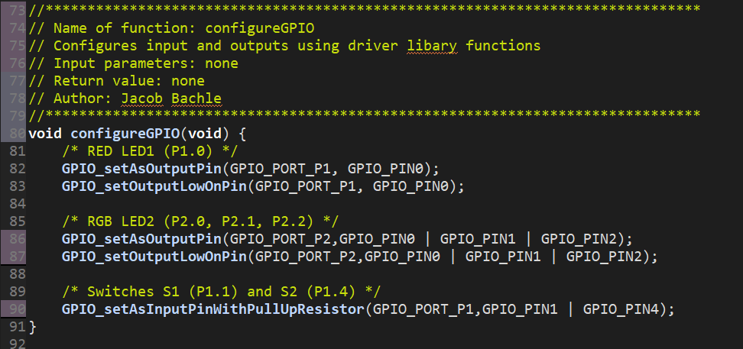
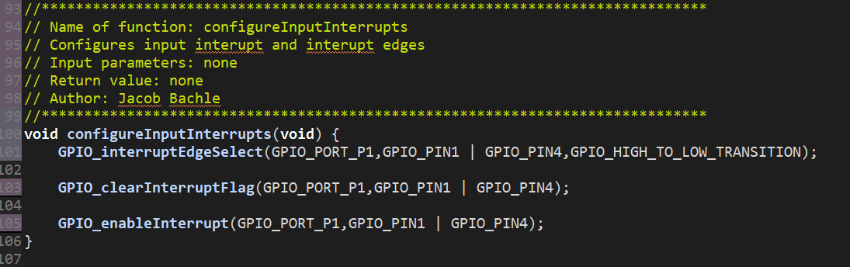
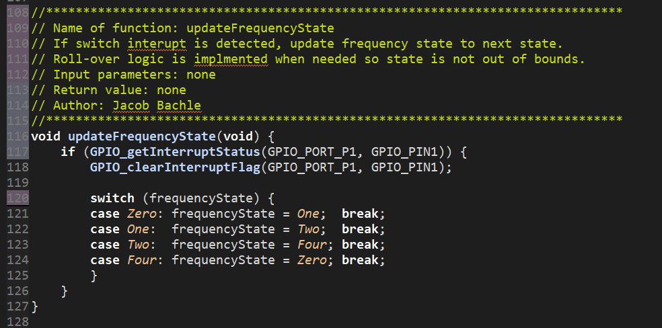
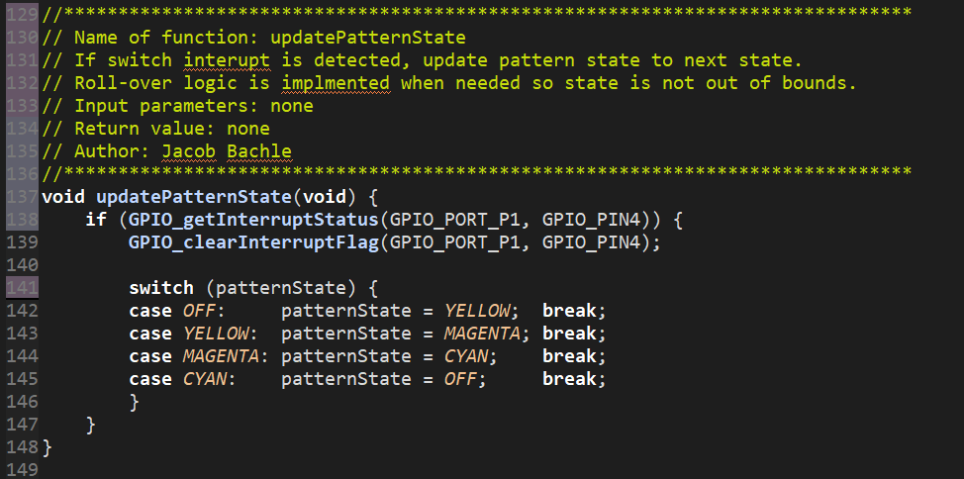
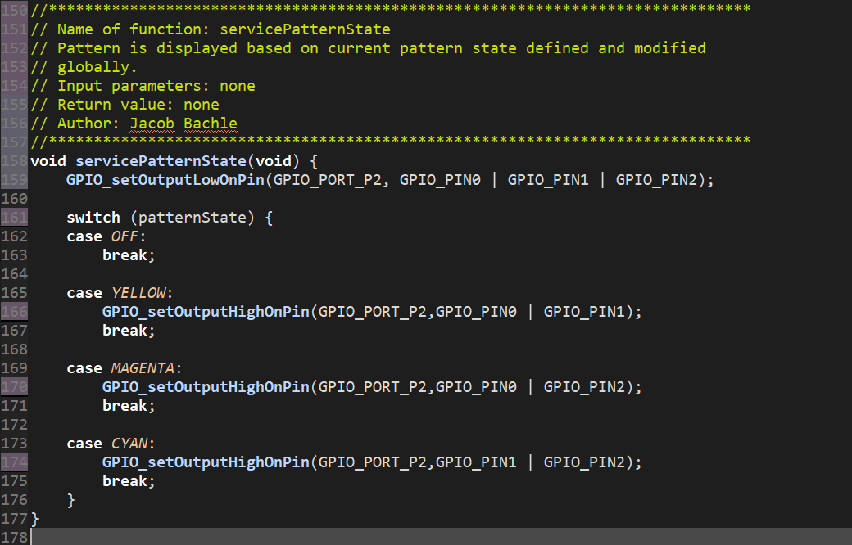
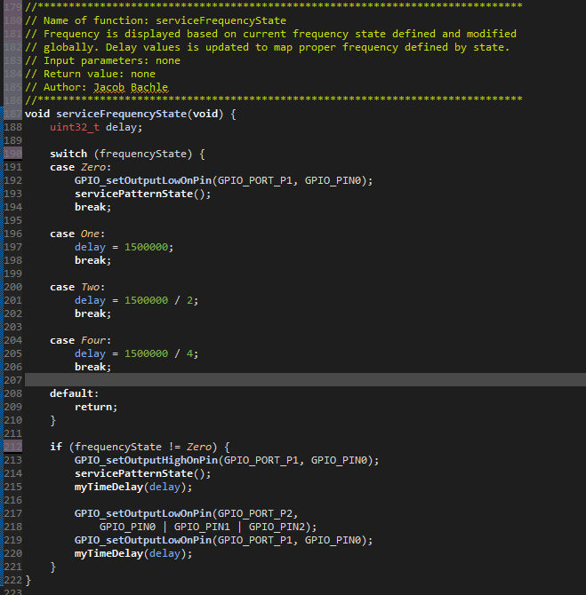

Experimental Results
The following certification is proof of design meeting design requirements.
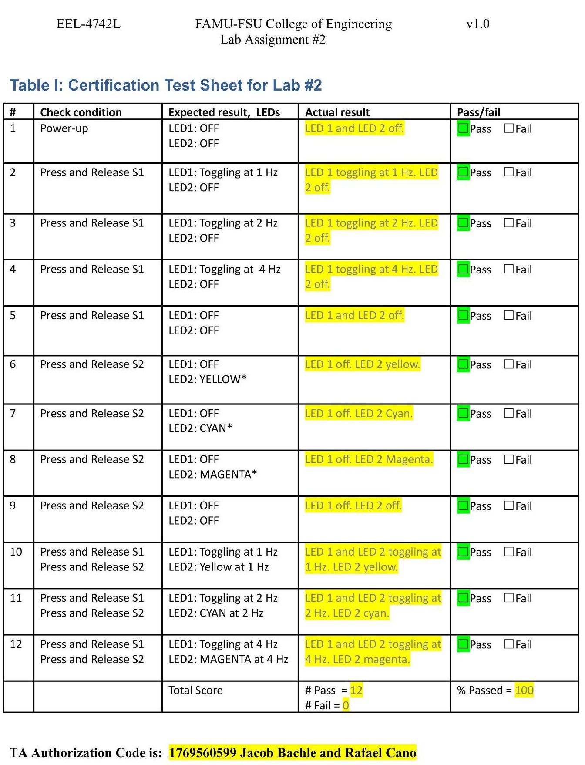

Summary
With the implementation of the previous logic defined in theoretical and synthesized design, all 12 out of 12 tests are passed. This means that 100% of the final design tests were passed and no further modifications needed to be made.

How did you implement having LED2 “appear” as a solid color when
LED1 is OFF?
When the LED 1 is in the off state, LED 1 is turned off and the servicePatternState() helper function is called. This just updates the colored LEDS to the most recent state.
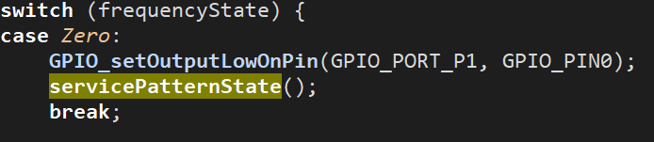

Lessons Learned
List of new concepts learned:
- Configure input pins with driver library functions.
- Configure output pins with driver library functions.
- Configure, clear, and check interrupts on a pin with driver library functions.

A modular approach was used so not all of the logic was contained in the main() function. This improved the modularity and the readability of the cover overall. In addition, the use of driver library functions made the code a lot more readable as well as less need for developer comments. This improved the efficiency and readability of developing the code and will be used in the future.

